Accepting Input from User
Java provides several ways for reading the input from the user.
1. Command Line Argument: it is one of the most common way of accepting the input in which a user will supply the value while executing the program
i.e.
java abc Administrator
will print
Hello! Administrartor
Example:
class A
{
public static void main(String args[])
{
System.out.println("Hello! " + args[0]);
}
}
//Example 2
class A
{
public static void main(String args[])
{

String title = args[0];
String fname = args[1];
String lname = args[2];

System.out.println("Title : " + title);

System.out.println("Firstname : " + fname);

System.out.println("Lastname : " + lname);

}

}
2. Using Scanner Class: The scanner class is provided in the java.util package so we have to import the package in our program and it is used to accept the input from the user.
Example of user input in string type using Scanner Class
import java.util.*;
class A
{
public static void main(String args[])
{
Scanner obj = new Scanner(System.in);
System.out.print("Enter Title : ");
String title = obj.nextLine(); //scanf()
System.out.print("Enter Firstname : ");
String fname = obj.nextLine();
System.out.print("Enter Lastname : ");
String lname = obj.nextLine();
System.out.println("Title : " + title);
System.out.println("Firstname : " + fname);
System.out.println("Lastname : " + lname);
String fullname = title + " " + fname + " " + lname;
System.out.println("Fullname : "+ fullname);
}
}
Note:
Standard Streams Provided by Java:
1. Input Stream ( System.in) i.e. Keyboard
2. Output Stream ( System.out) i.e. Monitor
1. Error Stream ( System.err) i.e. Monitor

Example of user input in an Integer type:
import java.util.*;
class A
{
public static void main(String args[])
{
Scanner obj = new Scanner(System.in);
int x,y,z;
System.out.print("Enter x : ");
x = Integer.parseInt(obj.nextLine());
System.out.print("Enter y : ");
y = Integer.parseInt(obj.nextLine());
z=x+y;
System.out.print("Result = " + z);
}
}
3. Using Console Class: The Console class has been added later on in the java platform to provide the user input in a interactive way.
It is defined in the java.io package so this must be imported in the program to use the Console class.
(a) readLine() - to accept input i.e. in string
import java.io.Console;

class HelloFirst4
{

public static void main(String args[])
{

Console obj = System.console();

String username = obj.readLine("Enter username : ");

System.out.println("Hello! : " + username);

}
}

(b) readPassword() - to accept secured input i.e. password, cardno.
import java.io.Console;

class HelloFirst5
{

public static void main(String args[])
{

Console obj = System.console();

String password = new String(obj.readPassword("Enter Password : "));

System.out.println("Hello! : " + password);

}
}

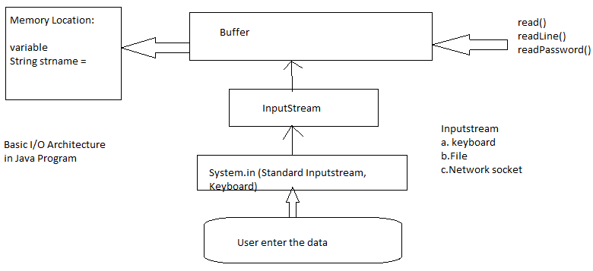
Basic IO Diagram

Java Language Fundamental:
1. variable :
Variable : It is the placeholder / named memory location where we store the data in it. Its value can be changed during the program.
Syntax for declaring variable :
<data_type> <identifier> = [value];
< > - compulsory
[ ] - optional
| - or
2. constant :
Constant : it has the fixed value that cannot be changed during the program.
To declare constant use final keyword
i.e.
<final> <type> <identifier>=<value>;
final int x=10;
Final can be declared and initialize at the same line or later on but on initialized its value cannot be changed.
Example:
class AA
{

public static void main(String args[])
{

final int a;
a=20;
System.out.print(a);
a=40;
}
}
3. data types :
Data Type : it is used to specify the type of value and range of value that can be stored in the given variable i.e. int, char, string, boolean etc.
Types of Data Type :
1. Primitive and Non Primitive Type
or
Simple and Complex Type
or
Value and Reference Type
Note : in case of value type the data is directly stored and accessible with the help of identifier, while in case of reference type the "reference" or address is stored using which we access the data indirectly i.e. pointers, objects etc.
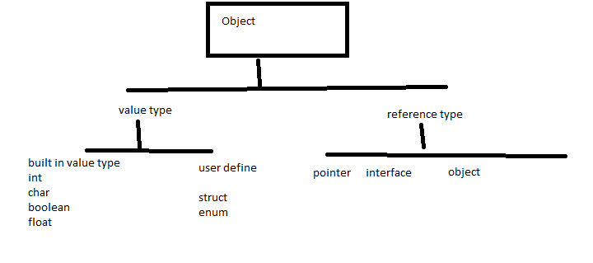

Data Type Casting / Data Type Conversion:
Data Type Casting : it is the process by which we can convert the data from one type to another type i.e. converting string to integer, decimal to integer or integer to string;
Type Casting can be of the following types:
- Implicit type casting
class test
{

public static void main(String args[])
{
char c='A';

int a = c;

System.out.print(a);

}
}

//to print alphabets
class test
{

public static void main(String args[])
{
for(int i=65;i<=90;i++)
System.out.print("\t" + (char)i);

}
}
//to print all ascii code
class test
{

public static void main(String args[])
{
for(int i=0;i<255;i++)
System.out.print("\t" + i + " = " + (char)i);

}
}
- Explicit type casting
Example:
class test
{

public static void main(String args[])
{
int a = Integer.parseInt(args[0]);
int b = Integer.parseInt(args[1]);
int c = a+b;
System.out.println("Result of a+b = " + c);
}
}
Implicit Type casting: in this type of type casting, the type casting is automatically handled by the compiler of the language and we don’ t need to write any extra code for it.
Explicit Type Casting: in this the user has to write the necessary code for type casting of the data.
Automatic Type Promotion:
Java provide the facility of automatic type promotion in which the lower types are automatically converted to their higher types i.e.
Byte-> short int->long int-> double
But in the same category
Example
class A
{

public static void main(String args[])
{
String str="10";
//converting from string to int (explicit)
int x=Integer.parseInt(str);
System.out.println("x = " + x);
int a=65;
//converting from int to char (explicit)
char c=(char)a;
System.out.println("c = " + c);
//converting from char to int (implicit)
int b = a;
System.out.println("b = " + b);
int d=5;
//converting from int to float (implicit)
//automatic type promotion
float f=d;
System.out.println("f = " + f);
int ff = (float)f*d;
int fff = Float.parse(f*d);
System.out.println("ff = " + ff);
}
}
Note :
- Loss of value (precision)
- Incompatible type
Example 2
class A
{
public static void main(String args[])
{
//converting from string to int (explicit)
int x=10;
String str= String.valueOf(x);
System.out.println("str = " + str);
}
}
Note:
Type casting will change the data only for the current expression, not for the entire program

literals - it is the value assigned to a variable
we can have following types of literals:
1. string literal : it is stored in double quote i.e
"ABC";
Example:
String name=”abhishek singh”;
String email=”abhi1234@gmail.com”;
A string is alphanumeric It can store alphabets i.e. abc, number i.e. 123 as well as we can also store special characters in it i.e. @, %,# etc. we can store set of characters
- char literal – it is in a single quote i.e. 'M', 'F'
char gender;
gender=’M’
char answer;
answer=’Y’;
it is also alphanumeric It can store alphabets i.e. abc, number i.e. 123 as well as we can also store special characters in it i.e. @, %,# etc, but we can store only one character at a time.
- floating point literal : 124.50
float rate_of_interest;
rate_of_interest=10.25;
- Integer literal : 10
Int salary;
Salary=8000;
- Boolean literal: it will store true/false or 0/1
Bool exam_passed;
Exam_passed=true;
4. Flow Control

Flow Control Statements
The flow control statements are used to control the flow of execution in the program.
we can have following types of flow control statements :
1. Conditional Statements: the conditional statement are used to evaluate a condition and based on that further action is performed.
we can have following type of conditional statements :
a. single line if -
Syntax :
if( <condition>)
statement
Note : no statement for else part
b. if else
Syntax :
if( <condition>)
statement
else
statement
Example:
class test
{

public static void main(String args[])
{

int age = Integer.parseInt(args[0]);

if(age >=18)
System.out.println("You can vote!!!");
else
System.out.print("You cannot vote!!!");
}
}
c. nested if : it is an if condition inside another if, the outer if is executed first and if it is true then the inner if will be checked and if both are true then the statement will execute.
Syntax :
if( <condition>) //outer if
if(<condition>) //inner if
statement
else
statement
Example:
class test
{

public static void main(String args[])
{

int age = Integer.parseInt(args[0]);

if(age >=18)
if(age <=25)
System.out.println("You can apply");
else
System.out.print("You cannot apply");
}
}
Compound statement
class test
{

public static void main(String args[])
{

int age = Integer.parseInt(args[0]);

if(age >=18 && age <=25)
System.out.println("You can apply");
else
System.out.print("You cannot apply");
}
}
d. if else if ladder : in case of multiple conditions we can have if else if ladder in which the if condition are executed one by one like a ladder, if first condition fails then the second will execute otherwise rest of the conditions will be bypassed.
Syntax :
if( <condition>)
statement
else if(<condition>)
statement
else if(<condition>)
statement
else
statement
Example :
class test
{

public static void main(String args[])
{

int age = Integer.parseInt(args[0]);

if(age <18)
System.out.println("You are minor");
else if(age >=18 && age <=40)
System.out.print("You adult and young!");
else if(age >40)
System.out.print("old!!!");
}
}
e. switch case : it is used to check multiple conditions like if else if ladder , but it is more structured so easy to implement and write down.
A variable is evaluated against the number of conditions and if anyone of them is satisfied then the corresponding statement block will get executed and the rest of the conditions will be ignored.
Syntax :
switch(<variable_name>)
{
case <condition>:
statement;
break;
case <condition>:
statement;
break;
default :
Statetment;
}
Note : default is like the else part that gets executed when no condition is satisfied.

f. ternary operator : it is also called the short form of if else statement in which we have one condition and two statement, the first statement is executed when the condition is true otherwise the second statement gets executed.
syntax :
<variable_name> = (condition) ? statement 1 : statement 2;

5. Operator ( logical, relational)
6. Arrays
7. Function
------

